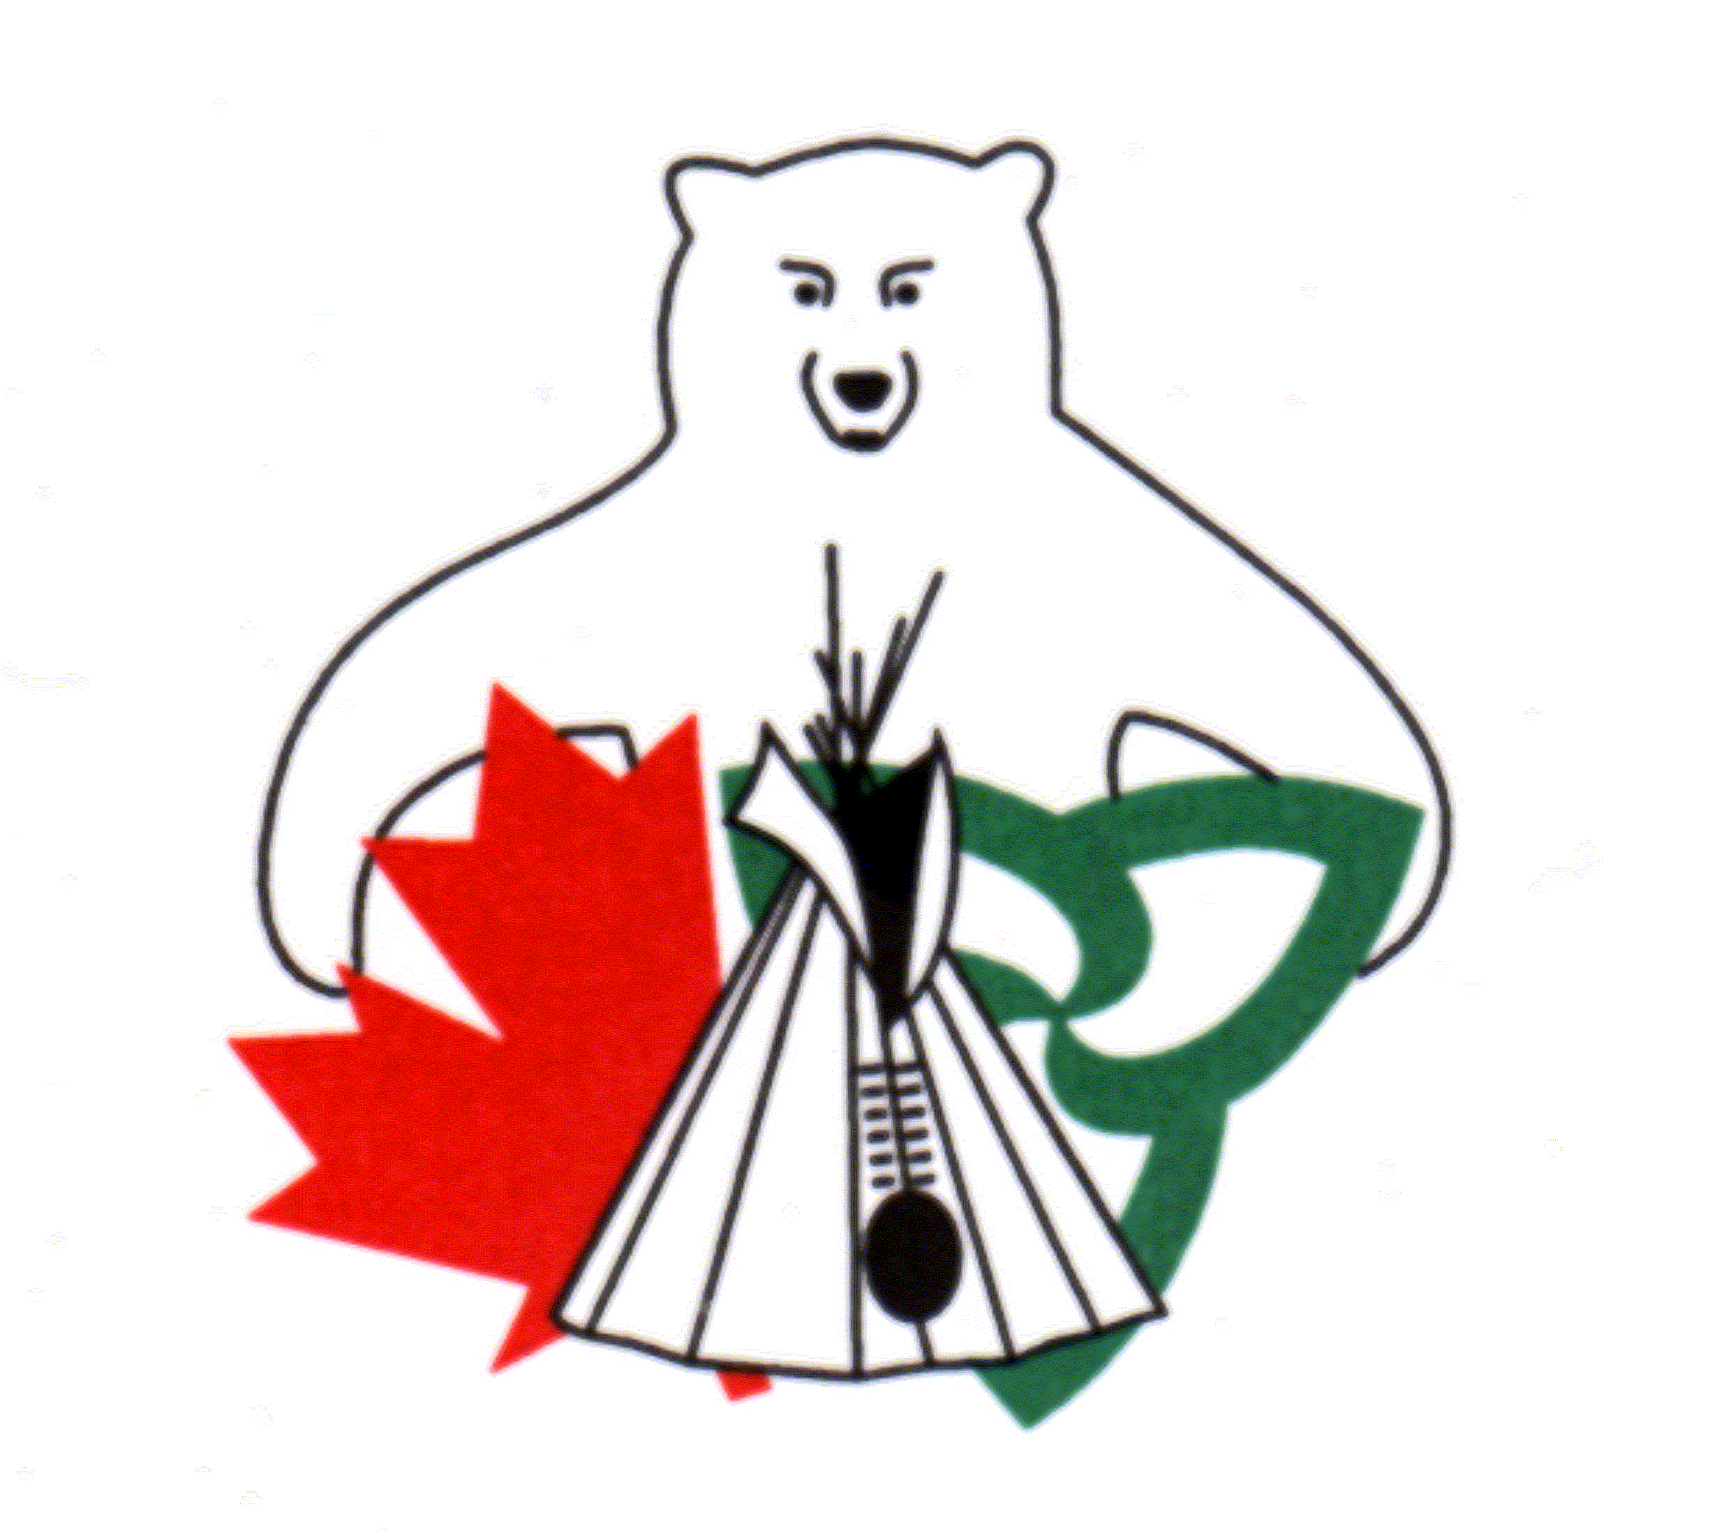
Canada Ontario Resource Development Agreement (CORDA)
2022-2023 Application Instruction Page

How to Apply:
The application form, in its original form, must be typed, completed in full and signed. Do not delete any of the questions or information contained within the application form. Attach all supporting documentation identified in Part 5 of the application form to your submission. For more details, please review the CORDA 2022-23 Application Guide Book.

Using the Form:
Complete each section by typing in the space below the question, providing as much detail as possible. If you require more space in any area, simply keep typing and the form will expand accordingly. Alternatively, you may attach separate pages with additional information. Do not adjust the formatting of the form. To use the check boxes (☐), click on the box you want to check.

Application Submission:
Send complete application packages to the CORDA Office by either e-mail, fax or regular mail. Only one copy of the application package is required. Applicants are encouraged to send an electronic application package to corda@hiawathafn.ca. You may send multiple e-mails if needed to ensure submission of all attachments.

Deadline to Apply:
Applications must be submitted to the CORDA Office by 11:59 p.m. Eastern Standard Time Monday, October 4, 2021. Applications received after the deadline will not be considered.

Additional Information:
Funding for 2022-23 and beyond is subject to confirmation. Applications will be reviewed in anticipation of funding availability. Final approval of projects will be based on the confirmation of funding.

Incomplete, unsigned or late applications will not be considered. Submission of an application does not guarantee approval for funding. Please note, each year CORDA receives many excellent applications but can only fund a portion of the submissions under this competitive process. Applicants will be notified in writing once funding decisions are finalized.

All applications will be screened for necessary Northern Development, Mines, Natural Resources and Forestry permits and/or licenses.

CORDA Office Contact:
Laura Howard, Secretariat
E-mail: corda@hiawathafn.ca
Phone: 705-295-4421

Please do not submit this instruction page with the completed application form.

Canada Ontario Resource Development Agreement (CORDA)
Internal Use Only: Project #: _____________________ MNRF District: ____________________________

2022-2023 Application Form

Part 1: Applicant Information
Name of Applicant: (Individual, First Nation or Organization)

Name of First Nation of which the applicant is a member:

Treaty Organization the First Nation is a member of:
☐ Grand Council Treaty #3
☐ Anishinaabek Nation (Union of Ontario Indians)
☐ Nishnawbe Aski Nation
☐ Association of Iroquois and Allied Indians
☐ Independent First Nation

Name of Contact Person (if different from applicant):

Position or Title of Contact Person:

Contact Information:
Address: (Street Number, Street Name, Unit Number):
P.O. Box Number:
City/Town:
Postal Code:
Telephone Number:
E-mail Address:

Part 2: Project Details
Project Title. Choose a concise title that explains the purpose of the project. For example, “Updated Equipment for Commercial Fishing Enterprise”.

Project Objective. List the expected results in two or three sentences or bullets. For example, “The project will result in increased revenue or jobs,” or “The project will add value to the product”, or “The project will result in improved fishing with new nets and gear”.

Project Description. You may attach additional pages if required to complete this section. Provide a detailed description of the project including how the funding will be spent and how the project will be undertaken. Describe the major milestones (steps) and what will be accomplished. Include any photographs or diagrams that may support the project. Identify other agencies or groups that were consulted. You may attach additional pages if required.

Project Location. Describe the location of the project activities. Please include the address if applicable.

Check whether the project activities will occur on or off a First Nation reserve:
☐ On First Nation reserve
☐ Off First Nation reserve

All applications must include a map identifying the location of the project activities. An online mapping tool can be accessed here. (https://www.lioapplications.lrc.gov.on.ca/Natural_Heritage/index.html?viewer=Natural_Heritage.Natural_Heritage&locale=en-CA)

Natural Resource Management. To be eligible for CORDA funding, projects must promote natural resource development, management, harvesting or conservation in Ontario. Please refer to the Guide Book for a complete list of eligible projects.

What natural resource is being managed?

Describe how the project will contribute to the management of that natural resource both in the short and long term.

Project Duration. Indicate the project start and completion date. Projects will only be reimbursed for costs incurred as of April 1, 2022 and must be complete no later than February 24, 2023.

Start Date:
Completion Date:

Previous Applications. Has the applicant previously applied to CORDA for funding for this project?
☐ Yes
☐ No

Previous Funding. Has the applicant received previous CORDA funding for this or any other project?
☐ Yes
☐ No

If yes, please list previously approved project, including project number or the year the funding was received, the project title, and/or other project details.

Environmental Impact. Some applications may be subject to a federal environmental screening process. Any project on federal land, including reserve lands, that involves the construction of a new building or repairs to an existing building, or will produce any waste that is not household waste requires the completion of an environmental review process through Indigenous Services Canada. Successful applicants who are subject to this environmental screening will be notified about the process.

Does the project have the potential for positive effects on air, water, soil, land, etc.?
☐ Yes
☐ No

If yes, describe the positive impacts the project will have to the air, water, soil, land, etc.

Does the project have the potential for negative effects on air, water, soil, land, etc.?
☐ Yes
☐ No

If yes, describe actions that will be taken to reduce the negative environmental impacts. Environment and Climate Change Canada or the Ministry of the Environment Conservation and Parks may be a resource for information on assessing environmental impacts.

Part 3: Project Benefits
Provide details on the short and long-term benefits of the project. Use additional pages if required.

Indicate whether the project focus is for
☐ Traditional practices, or
☐ Commercial enterprise

Economic Benefits. Provide details on the following economic benefits:

Check if the funding will be used to assist a new business or an expanding business:
☐ New Business
☐ Expanding Business
☐ Not applicable

Provide details on any jobs that will be created as a direct result of this project, including the duration of each position (for example, contract, seasonal, permanent) and whether the positions are part-time or full-time.

Describe how the project involves First Nation community procurement. For example, provide details on any supplies to be purchased locally.

Estimate how much revenue will be generated:
☐ Not applicable
Short Term: $
Long Term: $

Cultural Benefits. Provide details on the following benefits related to Traditional Knowledge and cultural values.

Describe how the project will use and support traditional cultural knowledge/values.

Describe how the project results in the transfer of traditional cultural knowledge/values.

Describe how youth from the community will be involved.

Overall Benefits. Provide details on the following overall benefits:

Does the project include training?
☐ Yes
☐ No

If yes, estimate the number of people to receive training during the project:

Describe the type of skills that will be learned and/or developed.

Estimate the number of project participants, including volunteers.

Does the project support a community plan, such as an economic, land use, forestry, or other plan?
☐ Yes
☐ No

If yes, name the plan and describe how the project supports the plan.

List the anticipated community benefits resulting from the project.

Identify partnerships that will result from this project, including partnerships with other First Nations, municipalities, conservation authorities or academic institutions.

Part 4: Project Costs / Budget
Have you applied to other funding sources for this project?
☐ Yes
☐ No

If yes, provide details including the name of the funder and the amount requested and/or approved.

Budget Instructions: Provide a detailed project budget. The budget information will be compared to supplier quotes submitted with the application. The maximum funding level for CORDA projects is $35,000.00. In the chart below, list each item, the number of items requested, and the cost of each item. Any In-kind contributions from the applicant should be identified. Attach a separate sheet if additional space is required. See the Application Guide Book for eligible expenses.
Category | Details | CORDA Request ($) | Applicant Contribution ($) | Other Funding Sources ($) | Total ($)
Example | Portable Sawmill | 30,000.00
 | Trailer, | 5,000.00
 | Chainsaws x 4 |  | 800.00
 | Safety Equip. |  | 600.00 |  | 36,400.00
Equipment
Materials
Labour
Transportation
Other
 | Total CORDA Request |  |  | Project Grand Total

Part 5: Support Documents
All applications must include supporting documents to be considered complete. It is recommended applicants submit additional supporting documents, depending upon the type of project.

Check the attachments included with the application:
Required for all Applications:
☐ Supplier Quotes for all proposed expenditures
☐ A demonstration of community support by either a letter from the Chief, a member of Council or a First Nation Council Resolution (FNCR). Applications where the First Nation is the applicant must include an FNCR. Applicants cannot sign their own support letter.
☐ A clear map(s) showing the specific location of the proposed activities

Recommended additional supporting documents:
☐ Photographs
☐ Relevant permit or licenses such as commercial fish license or trapping license
☐ Additional supporting documentation such as a business plan or Community Economic Development Plan
☐ Other documents. Please Specify:

☐ I consent to the publishing of my name, funding and project description in the 2022-2023 CORDA Annual Report to be distributed to government partners and the public.

Use of Personal Information
Personal information on this form is obtained under the authority of Section 13.1 (1) of the Northern Development, Mines, Natural Resources and Forestry Act, Section 8, R.S.O. 1978. The information submitted in this application is to assess the applicant’s request for funds under the CORDA program. The financial and technical information will be used to determine eligibility of the application to have a program designated, for financial assistance and the amount of such assistance, for audit purposes and for project summary review. Questions or concerns regarding use of personal information should be directed to Chair, Canada Ontario Resource Development Agreement, c/o Northern Development, Mines, Natural Resources and Forestry, Integration Branch, 300 Water Street, 5th Floor, South Tower, Peterborough, ON K9J 8M5 or by phone at (705) 760-1892.

Declaration
I declare that I am a First Nation member or an official of a First Nation organization or a Treaty organization in Ontario and that the information in this application for a Canada Ontario Resource Development Grant is true, correct and complete in every respect. I hereby authorize the CORDA Committee through his/her representatives to make such enquiries, undertaking such discussions and share such information with other public and private agencies with respect to my application as she/he may in his/her discretion deem necessary for the evaluation and assessment of the proposal.

Applicant Signature: _________________________________________________
Name and Title: ____________________________________________________
Date: _____________________________________________________________

The complete, signed application package can be submitted as follows:

By Regular Mail | or | By e-mail | or | By fax
Secretariat  CORDA Office  431 Hiawatha Line  Hiawatha, ON K9J 0E6 |  | corda@hiawathafn.ca |  | 705-996-4501

Applications must be received by the CORDA Office no later than 11:59 p.m. EST on Monday, October 4, 2021. Late submissions will not be accepted.

