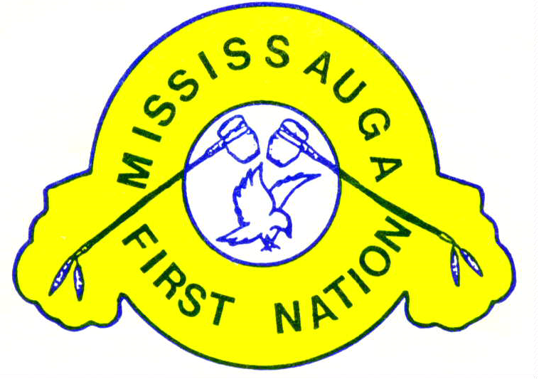
2018
Mississagi Trust Application Guidelines
All Streams

Approved: December 6, 2018

ABOUT MISSISSAGI TRUST
In April of 1994 the Northern Boundary Land Claim Settlement Agreement was approved by the Mississauga First Nation membership. The Mississagi Trust Agreement was created as an integral part of the voter approved Land Settlement Agreement with five Trustees, initially appointed. Part of the Trust agreement was to have the Trustees manage the land claim settlement money $12.5 Million in accordance with the Trust Agreement. As per Section 13 Buying Land, the Trust had to spend approximately $2.5 million on land purchases. As per Section 14 of the Trust Agreement, the Trustees are responsible to “invest the money carefully and use it wisely for the benefit of present and future generations of the band members of Mississauga First Nation”. The Trust Agreement specifies how the revenue moneys (interest) can be spent as per Section 6.3, (a–r).
The number of provisions that outline how the Revenue or interest monies could be used for clearly identifies the “spirit of intent” for “community development and growth”. Out of the eighteen (18) provisions that outline how the revenue moneys can be used for, twelve (12) are directly related to community development and growth.

HOW THE INTEREST EARNED IS SPENT
The following chart shows how the interest that is earned on the community trust investments is divided on a percentage basis. The dollar amount earned in each year is not the same and so the amount of money available for community projects and community members will change each year.
- The cost of operating the trust is approximately 35% of the interest.
- Each year up to 65% is being proposed to be spent on community projects (15%), community plans (33%) and community member (17%) support initiatives regardless of residency as per the proposed Trust Revenue application package.

How the interest will be spent for community members and community projects:
Sixty-five percent of the remaining earned interest will be spent on proposals. There will be three (3) separate Streams. Each Stream has requirements that need to be met in order for the projects to be approved. Approvals will be based annually on a “First-come, first-served” basis, or essentially when the funding allocation under each stream have been exhausted. Remaining applications will be placed on a wait list for the following fiscal year.
- Comprehensive Community Development Plan Stream
Thirty-three percent (33%) of the interest set aside for proposals will be spent on the Comprehensive Community Development Plan Stream. These dollars will be set aside for community projects or initiatives that have been identified as priorities in the Mississauga First Nation Comprehensive Community Development Plan, 2013. The community planning process involved and continues to involve, community membership participation. The Comprehensive Community Plan has been accepted by Chief and Council and becomes the guide for community development. The Community Plan is meant to be a living strategic document that can be revised annually with new initiatives added as needs arise.
The Community activities in the plan will be considered on an individual basis each year by the Trustees based on the applications submitted by the First Nation programs, endorsed by Administration and recommended by Chief and Council through a Band Council Resolution. Applications must meet the terms and conditions set out in the guidelines.
- Community Projects Stream
An additional fifteen percent (15%) will be spent for one-time community projects/equipment/ infrastructure that are under fifty thousand dollars and not identified in the community plan.
The Community activities in this stream will be considered on an individual basis each year by the Trustees based on the applications submitted by the First Nation programs, endorsed by Administration and recommended by Chief and Council through a BCR. Applications must meet the terms and conditions set out in the guidelines.
- Community Membership Stream
The Community Membership Stream will be allocated seventeen percent (17%). Band members regardless of residency can apply for support for the items listed in these guidelines based on the criteria set out for each type of assistance requested. There are three (3) items or initiatives that community members can access for “limited financial support”. All requests must prove that other funding sources have been exhausted and funds cannot be accessed elsewhere. Applications must meet the terms and conditions set out in the guidelines however individual
applications are not reviewed nor do they require recommendation from administration or Chief and Council.
Small business applications must show proof of utilizing all other resources involvement in business development such as FEDNOR, Waubetek and Community Futures Development Corp.
Support items include the following:
Education: Courses/workshops/training, books and equipment
Health: Medical treatments, medications, other medical costs
Small Business: Capital investment, expansion and summer student

EXAMPLE ONLY of Investment Revenue Breakdown
On average over the past number of years the Trust has earned an annual interest of approximately $300,000. Based on this amount of annual revenue the breakdown for each allocation is represented in the following table:
Operation of Mississagi Trust | 35% | $105,000
Proposals | 65% | $195,000

Of the $195,000 for proposals the breakdown is as follows:
Community Plan Stream | 50% | $97,500
Community Projects Stream | 24% | $46,800
Community Membership Stream | 26% | $50,700
TOTAL |  | $195,000

The amount available each year for each stream will be different as interest amounts earned from investments depends on the world economy. The Trustees will determine the breakdowns once the audit has been completed.

Community Membership Stream
The intention of this funding stream is to support Mississauga First Nation Band members regardless of residency.

Who can apply:
Registered Band Members of Mississauga First Nation living off or on reserve 18 years of age and older can apply under this stream. Parents or legal guardians can apply on behalf of their registered band member children. Youth 14 to 24 are eligible to apply for the summer student business funding. Depending on request, applicants may be required to provide proof that they have exhausted alternative funding sources and sign a consent form that these sources can be contacted for confirmation. No individual will be provided with the financial assistance but rather an invoice must be issued by the company/source to the Trust Manager who in turn will pay the invoice, on behalf of the community member.
What can be funded:
The following can be considered for financial support by the Mississagi Trust:
Education: Lifelong learning is important. It is often difficult to access money to take professional development or training courses. The Mississagi Trust will consider applications for financial support for courses, books and equipment that are not funded by other First Nation programs. This would include language courses and camps and driver’s education.
- Professional development course fees, workshop costs or training costs that will help an individual build their skills to help them in their job or to get a better job can be considered by the Mississagi Trust.
- Books must be directly related to courses that are being taken by the applicant.
- Equipment could include specialty computer software that would be required by a student that is not otherwise covered.
Health: Band member health is important to the wellbeing of the First Nation. Medical treatments, medications and other medical costs not otherwise covered under health benefit programs will be considered by Mississagi Trust.
- Medical treatments such as traditional medicine, homeopathy and other alternative medical treatments that are not covered by health benefits are eligible.
- Traditional medicines and other medications that are needed to treat a specific illness are considered eligible.
- Other medical costs.

Funding limits
The following table outlines the limits for each eligible item under the Community Membership Stream.
ITEM | LIMITS
Education
Courses/workshops/training | - Maximum of $2,500 for the length of this agreement
Books & other fees related to the course | - Maximum of $1,000 for the length of this agreement
Equipment | - Maximum of $1,000 for the length of this agreement
Health
Medical Treatments | - Considered on a case by case basis
Medications | - Considered on a case by case basis
Other Medical Costs | - Considered on a case by case basis
Business

Please see steps listed on page 14 before requesting an application
Capital Expenses | - 25% of eligible costs to a maximum of $25,000
Expansion | - 25% of eligible costs to a maximum of $20,000
Summer Student  14 – 24 Years of Age | - 60% of start-up costs to a maximum of $1,000  - One time only

Application Process

The approval process is the same for all community members regardless of residency.
Band Member Submits
Application
Monthly Trustee Meeting
Review and Evaluate
Applications
Trust Manager
Reviews Application- anremoves
Applicant requested to complete application correctly
Letter sent to applicant Application proceeds to next step
Incomplete Application
Complete Application
Cheque Issued to provider upon receipt of invoice(s)
Letter sent to Applicant
Outlining Approval Terms
Decision made

Not Approved
Approved
Trust Manager
Monitor & Follow Up
If Required
Letter sent to Applicant
Justification Report

Filling in the Application Form
The electronic application form needs to be filled out completely by the Band Member prior to being submitted to the Trustees for review. There are separate application forms for small business requests. The questions in each section need to be completed as fully as possible. There are three sections to each application form under the Band Membership stream. If you have difficulty filling out the form or are unable to complete it electronically contact the Trust Manager.
Community Membership Application Forms (17%)
Section A - Asks for information about the Band member. You must include your Band Number and provide a photocopy of your status card along with the application form. If you have applied for funding from the Mississaugi Trust before you must indicate so by checking the appropriate box. The amount you requested, when you requested it and if it was approved must also answered for all application forms. Indicate if the application is for yourself or your child who is under the age of 18.
Section B – Outlines the purpose of your request. Check the most appropriate box in the first column of the table. Then, using the drop down menu, select a description that closely matches your request. In the third column provide details about your request. For example, if you are asking for funding for a training workshop, give details about what the workshop is about, who is doing the training and where the training is taking place.
You are then required to indicate how much you are asking for from the Mississagi Trust. A copy of the advertisement or a quote must be provided with your application that clearly identifies the third party who the payment will go to if the application is approved.
In the space provided briefly explain why this important to you or your child.
Section C – Acts as the final report for this type of application. You are required to provide a brief acknowledgment letter (except in the case of the application relating to a health issue) explaining how the funding has benefited you or your child. If approved your acknowledgment comments may be published in the newsletter. A signature is required confirming that the information you are providing is accurate and that you agree to the funding terms and conditions of Mississagi Trust.
Complete the checklist and submit your application to the Trust Manager.
The application must be signed and dated confirming the information is accurate. Individuals who are 18 or older may sign the form themselves. For those who are under 18 a parent or guardian must sign the application on their behalf.
Once signed and the appropriate checklists have been completed the application and all supporting documentation is to be submitted to the Trust Manager.

Approval Process
The Community Membership Application forms are to be completed in full by Mississauga First Nation Band Members. They are then to be submitted to the Trust Manager along with all required attachments. The Trust Manager will review the applications. If an application is incomplete the Trust Manager will send a letter to the Band Member requesting that the missing information be sent to the Trust. Once received by the Trust Manager a unique identifier number will be assigned to the application form. The first page of the application form will be removed so that no individual can be identified. Then the remaining parts of the completed application along with supporting documentation will be submitted by the Trust Manager to the Trustees at their monthly meeting. In order for an application to be considered it must be given to the Trust Manager fifteen days prior to the meeting of the Trustees. Applications received after the fifteen-day timeframe may not be reviewed until the next monthly meeting of the Trustees.
The money that is available on an annual basis for the Band Membership stream is limited and it is the job of the Trustees to make sure that all Band members have an equal opportunity to access funding support. All applications will be considered in a consistent manner using established application guidelines of the membership stream and following program guidelines. To ensure unbiased and objectivity, the Trust Manager will remove individual names from the application and assign a code number to that individual. The Trustees will only receive the application with the coded number.
From time to time the Trustees may have to allocate less than what was requested in the application form.
Once the Trustees have reviewed and evaluated the application they will decide on whether or not the application can be approved based on availability of funding allocated under this stream. The Band Member is notified of the decision of the Trustees within three business days following the meeting. If the application is approved the Trust Manager will contact the vendor or supplier of the item or service and inform them that the invoice should be sent directly to the Trust Office for payment.
Accompanying Policies
All applicants may appeal the decision of the Trust by following the Trust Appeals Policy.
A Trust risk management policy is developed and will be applied to ensure that all submitted applications and requests including approved and declined requests, will be recorded, reviewed and published annually for community transparency.
All applications under all three (3) streams will be reviewed annually and if changes identified by community membership, Administration and Chief and Council are consistently being flagged over a two to four year period, then the Trustees will have the authority to make minor amendments to the three streams, such as changing percentage amounts and including other support items under the Community membership stream.
For more information or inquiries regarding the proposed Trust revenue guidelines and process please contact Claudette Boyer, Trust Manager at 705-356-1621 ext. 2206
claudetteb@mississaugi.com.

