Introduced March 6, 2018
Revised April 9, 2018
Committee Approval Date
Chief & Council Approval Date

Mino-Naakinagewin Mazina’igan
Chi-Naakinagewin Department

Contents
INTRODUCTION 2
Rule of Law 2
UNDERSTANDING 4
PLANNING 5
Deciding Whether a Law is Needed 5
Strategic Planning 5
Prioritizing and Managing Law-making Activity 6
Review and Approval by Council 6
CREATION 7
Drafting 7
Revision 7
CHI-NAAKINAGEWIN PROCESSES 8
Misswezahging Constitution 8
Constitution Law Making Process: 9
Chi-Naakinagewin Flowchart 10
MFN LAND CODE PROCESSES 11
Land Code Law Making Process: 11
Land Code Flowchart 13
Registry of Laws 14
Law Development Form 15
Drafting Instructions Form 16
Tracking Form 17

INTRODUCTION
The making of law is arguably the most important activity of MFN Chief & Council. This handbook describes the framework for this activity and the principles that govern it. It is of the utmost importance that leadership and administrative department utilize this guide to ensure adherence to a good law making process. The following are some of the mail goals of this handbook:
- Guide law makers through Misswezahging Constitution law making process;
- Guide law makers through Mississauga First Nation land law making process;
- ensure that proposed laws respect Anishinaabe Naakinagewin;
- ensure that the Council has the information and other support it needs to make sound decisions about proposed laws;
- ensure that Chief & Council considers any conflict of laws with Canada;
- ensure that laws fall under the law making powers outlined in the Constitution;
- ensure that laws do not conflict with Misswezahging Constitution provision concerning Citizen’s Rights and Freedoms (section 19) or Canadian Charter of Rights and Freedoms;
- consider the enforcement of any law initiative during the drafting process;
- make it clear that law-making initiatives can be very complex and must be properly planned and managed; and
- ensure that Chief & Council officials who are involved in law-making activities understand their roles and have the knowledge and skills they need to perform their roles effectively.
This Handbook sets out principles and general directions on how these objectives are to be met.

Rule of Law
There are core principles of law-making, both for Anishinaabe people and globally. Anishinaabe Rule of Law is something that is not written, the study of Anishinaabe legal system and articulating the knowledge held in written form has still not caught up to the breadth of traditional knowledge. However, there are a number of principles, outlined in the Misswezahging Constitution:
- Laws must consider the impact on the Seventh Generation.
- Laws should consider that Anishinaabe people have a free mind, they make decisions for themselves and have the right to Mino-Bimaadziwin.
- Laws should respect the Seven Grandfather’s Teachings of the Misswezahging
- Laws should preserve and promote the peace, unity and well-being of Misswezahging
- Laws should provide effective and accountable government to the citizens of Misswezahging
Derived from internationally accepted standards, the World Justice Project’s definition of the rule of law is a system in which the following four universal principles are upheld:
- The government and its officials and agents as well as individuals and private entities are accountable under the law.
- The laws are clear, publicized, stable, and just; are applied evenly; and protect fundamental rights, including the security of persons and property.
- The process by which the laws are enacted, administered, and enforced is accessible, fair, and efficient.
- Justice is delivered timely by competent, ethical, and independent representatives and neutrals who are of sufficient number, have adequate resources, and reflect the makeup of the communities they serve.
These principles are to serve as guides in the development and implementation of a transition between oral and written legal systems.

UNDERSTANDING
This guide sets out the expectations of Chief & Council in relation to the process for making Mississauga First Nation laws and regulations and generally orients the activities of MFN leadership in this process.
Officials involved in law-making activities must understand the fundamentals that underlie our developing system of law. They must also appreciate the steps involved in these activities as well as the need to plan them.
Mississauga First Nation (MFN) ratified the Misswezahging Constitution on March 9, 2015. The legal position of First Nation communities is unique, we are a self-determining entity who has made treaty with the government of Canada. Historically, Canada has determined Indigenous peoples to have surrendered law making authority to Canada. Through a number of legal victories in the Canadian court, Indigenous nations in Canada have begun to revitalize their legal authority and governmental jurisdiction. The path to legal reconciliation may start with the assertion of our law making authority.
On June 2, 2009 Mississauga First Nation ratified the MFN Land Code under the FNLMA Framework Agreement made with the Government of Canada. This system of legal development derives from recognition of land management laws under the First Nation Lands Management Act by Canada. Laws made under this regime have the advantage of being recognized by the Canadian government.
The leadership of MFN must decide upon the content of the law whether it should be passed under the Constitution, the Land Code or both.

PLANNING

Deciding Whether a Law is Needed
Making a new law, whether by obtaining Chief & Council assent to a code or by making regulations, is just one of several ways of achieving Chief & Council policy objectives. Others include policies, agreements or guidelines. In addition, a law may include many different kinds of provisions, ranging from simple prohibitions through a wide variety of regulatory requirements such as licensing or compliance monitoring. Law should be used only when it is the most appropriate.
The decision to address a matter through a code or regulation is made by Council on the basis of information developed by administrative departments assisted by the Chi-Naakinagewin department. The information must be accurate, timely and complete. To provide it, a department should:
- analyze the matter and its alternative solutions;
- engage in consultation with those who have an interest in the matter, including other departments that may be affected by the proposed solution;
- analyze the impact of the proposed solution; and
- analyze the resources that the proposed solution would require, including those needed to implement or enforce it.
There are a few methods that can be used to start to process:
- The program set out by Chief & Council
- Direction by Chief and/or Councillor(s) at a regularly scheduled meeting.
- Proposal by a member to Chief & Council, and an approval of the process.
- A Legal Development Proposal (Form 1), which a Director must present to obtain the Chief’s approval for the code to be drafted by the Chi-Naakinagewin Department.
  - Efficiency
When a law making initiative is being considered, and where it is appropriate and consistent with legal drafting principles, related matters should be combined in one code, rather than being divided among several codes on similar subjects. A single code allows Council to make the most effective and efficient use of their time for debate and study in committee.

Strategic Planning
Each year Chief & Council and the Senior members of the administration do a joint Strategic Planning session. If there are matters that require a Code, Law or Policy to be drafted this is where they shall be identified.
Immediately after the orientation process for a new Chief & Council, the Chief & Council Secretary will communicate with all Program Directors and Managers asking them to submit any proposed laws, policies or strategies. Subsequently, this “call letter” will be sent once per year (3 months prior to the annual Strategic Planning session) in order to deal with new or changing priorities.

Prioritizing and Managing Law-making Activity
At the first level, there is a Chief & Council-wide process to co-ordinate and set priorities among proposals for codes from different departments. For MFN administration, the Chi-Naakinagewin Manager supports the Council in this activity, as part of the overall scheme of the Strategic Plan developed by the Risk Management & Strategic Planning Director. In addition, the Chi-Naakinagewin Committee, supports and advises on legal issues requiring decisions by Council.
At the second, departmental level, each department manages the law making proposals in its areas of responsibility. It must ensure that it has allocated the resources necessary to carry its proposals through the law making process.
At the third, project level, departments must plan their law-making activities as they relate to particular codes or regulations. These activities are to be managed as projects with tools for determining what resources are needed, what tasks must be performed and what time frames are appropriate.

Review and Approval by Council
The proposals are prioritized by the Chief & Council and a tentative outline of the Governance Plan developed by the Chi-Naakinagewin Manager and Risk Management & Strategic Planning Director and Chi-Naakinagewin Committee for the for the following year. Long terms forecasts should to be developed every 5 years to outline as many legal priorities as is possible within the strategic plan.

CREATION

Drafting
It is essential that the Chi-Naakinagewin Manager or other responsible drafter have all of the necessary information to complete the draft law. Directors or sponsors should complete the appropriate Law Proposal form to the best of their ability. Should additional information be required, the Director should be prepared to support the drafting process.

Revision
Once a code has been drafted and approved by the responsible Director, the Chi-Naakinagewin Manager or other responsible director shall get the draft law reviewed a number of interested parties. There will be a Tracking Form completed chronicling the all the edits, but with particular attention to the policy questions that arise through the revisions.
At this stage the sponsoring department
- prepares material for use in explaining the code to community members;
- prepares a briefing note to be used by the Chief, Councillors, or Administrations when the code is referred to the community;
At each stage, Chief & Council shall be kept appraised of the progress of the draft law and will be provided with the Tracking Document when the law moves from one group to the next.
Following the final Community Meeting, the Chi-Naakinagewin Manager and sponsoring Director submits the code in its final form to Chief & Council to continue with the law making process.

CHI-NAAKINAGEWIN PROCESSES

Misswezahging Constitution
Chief & Council must only make laws in accordance with the subject areas outlined in the Misswezahging Constitution:
  - The Law Making Powers of the Misswezahging
(11) The Misswezahging have the inherent right given by the Creator to enact any laws necessary in order to protect and preserve our Anishinaabe culture, to protect our lands, our language, customs, traditions and practices. Each law enacted must be demonstrably shown to be for the betterment of the citizens of the Misswezahging, including but not limited to the power to enact laws in relation to:
a) how we select our leaders;
b) how we express and implement our inherent right of self-government;
c) the protection of our lands, waters and resources, including within our
traditional territories;
d) our education in accordance with our languages and cultural heritage;
e) the health of our citizens;
f) community support programs and services including, establishing
appropriate delivery standards and criteria to ensure fairness and equality;
g) establishment of any required agencies, boards, committees and other
governmental institutions;
h) the licensing and control of business activity within Misswezahging;
i) ways to help provide for and ensure the future economic prosperity of Misswezahging;
j) the protection of human rights;
k) additional legislative requirements for the passage of any Misswezahging laws beyond the minimal legislative requirements for enacting laws set out in this constitution;
l) the implementation of the spirit and intent of the Robinson Huron Treaty of 1850;
m) the establishment of any appeal tribunals or courts for the appeal of any laws or government administrative decisions;
n) rights, freedoms and benefits of citizenship in Misswezahging;
o) the prohibition of the sale, manufacture, distribution or promotion of narcotics and non-medically prescribed drugs within Misswezahging;
p) conflict of interest governing elected leadership and for administrative staff;
q) public and financial accountability;

(12) For greater certainty, the Misswezahging’s law making powers may only be exercised by the Council of the Misswezahging.
(13) Any enactments or amendments relating to Misswezahging land management laws or any decision by MFN Council to enter into any significant agreements on behalf of the citizens of Misswezahging, including self-government agreements, land claim agreements or impact and benefit agreements, taxation agreements or any other agreements that have the potential to significantly infringe or interfere with the exercise of the aboriginal or treaty rights of the Misswezahging must first obtain the approval of the citizens of Misswezahging through a community ratification process.
(2) Delegation of Authority
Delegation of Authority
(14) | The Misswezahging may delegate any authority in writing to any governmental institution;  Where authority is delegated to any governmental institution, the governmental institution to which the delegation has been made will be accountable to the Misswezahging government and to its citizens;

Constitution Law Making Process:
Law-Making Process
(15) | A draft law may be introduced at any meeting of Council:  a) By the Chief; and/or  b) By a Councillor(s);  However, no draft law may be introduced until three (3) months after a Council has been elected into office;
(16) | All draft laws shall be presented and read at a minimum of three (3) meetings of Council and discussed at, at least one community meeting;
(17) | A law shall be considered validly enacted after:  a) the draft law has been introduced and read to Council and discussed with the citizens at a community meeting in accordance with section 16 above;  b) the law has been passed by a majority of Council at a duly convened meeting of Council where a quorum of Council is present and in accordance with its rules and procedures;  c) the law has been signed by the majority of Council;  d) An official copy of the law has been registered in the Misswezahging registry of laws; and, after any other action as may be necessary to carry out the intent of the law has been taken.

Chi-Naakinagewin Flowchart
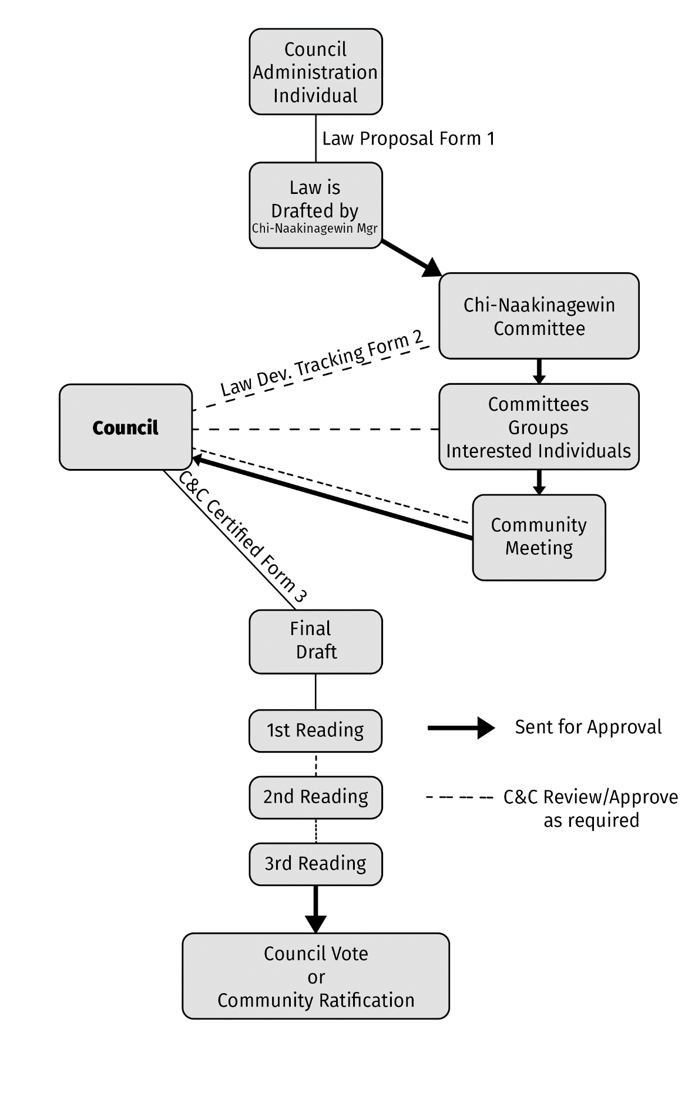

MFN LAND CODE PROCESSES

Chief & Council the following are the subject areas outlined in the MFN Land Code:
6. Law-Making Powers
Council may make laws
6.1 The Council may, in accordance with this Land Code, make laws respecting the development, conservation, protection, management, use and possession of Mississauga First Nation lands, and interests and licences in relation to those lands. This power includes the power to make laws in relation to any matter necessary or ancillary to the making of laws in relation to Mississauga First Nation land.
6.2 The following examples illustrate some of the laws that may be enacted:
(a) laws on the regulation, control and prohibition of zoning, land use, subdivision control and land development;
(b) laws on the creation, regulation and prohibition of interests and licences in relation to Mississauga First Nation land;
(c) laws on environmental assessment and protection;
(d) laws on the provision of local services in relation to Mississauga First Nation land and the imposition of equitable user charges; and
(e) laws on the provision of services for the resolution, outside the courts, of disputes in relation to Mississauga First Nation land.

Land Code Law Making Process:
7.1 A proposed law may be introduced at a duly convened meeting of the Council by
(a) the Chief or a Councillor;
(b) the representative of any body or authority composed of members that may be authorized by Council to do so, or;
c) any member over the age of eighteen (18) with fifty (50) witnessed signatures of eligible voters.
(d) Council may reject a submission under Section (c) above if it is of the opinion that the Council has dealt with a similar submission within the last eighteen (18) months.
Tabling and posting of proposed laws
7.2 Before a proposed law may be enacted by the Council, it must first be
(a) tabled at a meeting of the Council held at least twenty-eight (28) days before the law is to be enacted,
(b) posted in public buildings on Mississauga First Nation land at least twenty-one (21) days before the law is to be enacted; and
(c) deposited with the chair of the Lands Committee at least twenty-one (21) days before the law is to be enacted.
Urgent matters
7.3 The Council may enact a law without the preliminary steps required under Section 7.2, if the Council is of the opinion that the law is needed urgently to protect Mississauga First Nation land or the members, but the law expires twenty-eight (28) days after its enactment, unless re­ enacted in accordance with Section 7.2.
Approval of law by Council
8.1 A law is enacted if it is approved by a majority of the Council at a duly convened Meeting of Council where a quorum of Council is present and the meeting is open to members.
Certification of laws
8.2 The original copy of any law or resolution concerning First Nation land shall be signed by a quorum of the Council present at the meeting at which it was enacted.

Land Code Flowchart
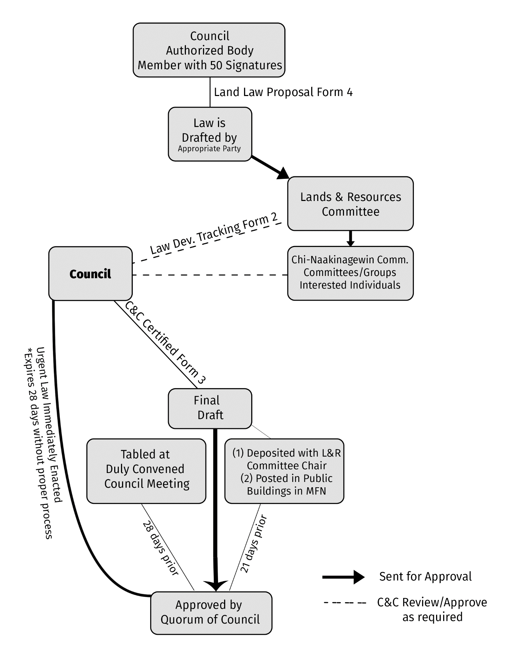

Registry of Laws

Following the approval process of the law, the original signed copies must remain with the Director of Operations. All laws must be made available upon the request of a community member. A copy must be kept available at the band office and also online on the official Mississauga First Nation website.

Law Development Proposal Form 1

INFORMATION
Law Name
Requested by (Name/Dept)
Requested Enactment Date
- attach any relevant documentation;
- analyze the matter and its alternative solutions;
- engage in consultation with those who have an interest in the matter, including other departments that may be affected by the proposed solution;
- analyze the impact of the proposed solution; and
- analyze the resources that the proposed solution would require, including those needed to implement or enforce it.
RATIONALE

OPTIONS

Approved by Chi-Naakinagewin Committee
Date
Additional Comments

Law Development Tracking Form 2

INFORMATION
Name |  | Purpose
First Draft |  | By
Revised |  | By

TRACKING
Review Date |  | Name/Committee
Policy Concerns

Revisions List

Chief & Council Certification Form 3

This is the certify that the law titled _________________ has been approved as a final draft.
The law will continue to __________________ (Readings/Vote/Ratification) on ___________ (date[s]).

Signed by the following members of Chief and Council:

__________________________________ __________________________________
Chief Councillor
__________________________________ __________________________________
Councillor Councillor
__________________________________ __________________________________
Councillor Councillor
__________________________________ __________________________________
Councillor Councillor
__________________________________ __________________________________
Councillor Councillor

Date: _____________________

Law Development Proposal Form 4

INFORMATION
Law Name
Requested by (Name/Dept)
Requested Enactment Date
Proposed Writer/Additional Resources
- attach any relevant documentation;
- analyze the matter and its alternative solutions;
- engage in consultation with those who have an interest in the matter, including other departments that may be affected by the proposed solution;
- analyze the impact of the proposed solution; and
- analyze the resources that the proposed solution would require, including those needed to implement or enforce it.
RATIONALE

OPTIONS

Approved by Lands & Resources Committee
Date
Additional Comments

